**HOW TO USE THE F12 FUNCTION TO SAVE TEMPLATES:**

F12’s or Templates can be setup on each screen and report throughout Quattro and enabled for Users, Groups and Globally for the company.

1. Go into your report (in this example we will use the Scheduing Edit Report). Fill out your **desired template items**. For this example Sales Market, Media Product Type and Operator have been selected.

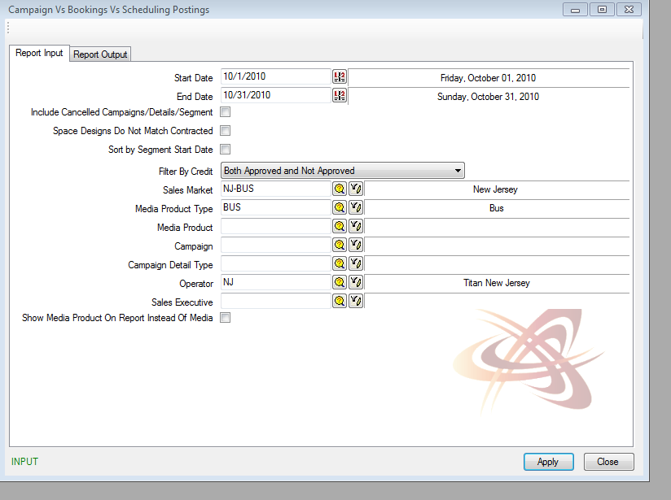

1. After filling out your selected fields press **F12 Key** (on your keyboard). Screen Template Screen will populate. **CTRL A** (Action>Add) Add mode to add a new template.

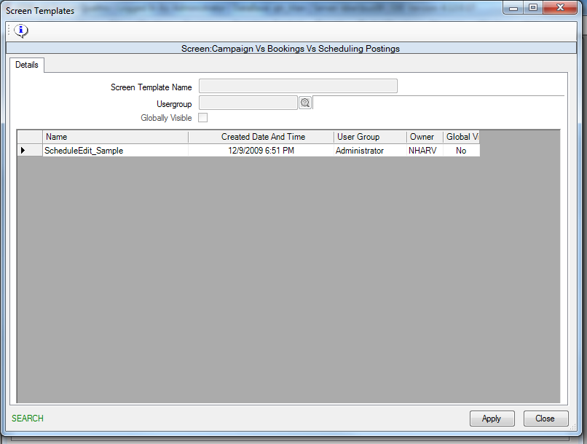

1. Important that we enter the Screen Template **Name: Example NJ-Bus Scheduling Edit**

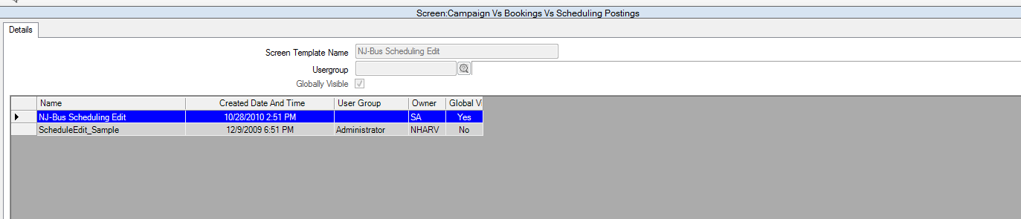

**Specify Visibility Options:**

1. **User Only**: only user has visibility (do not select anything)
2. **Specific User Group:** Ex. Chartists only (select user group for User Group Field)
3. **Globally Visible:** Available Globally (select checkbox Global Visible) - if you are making a Template Globally visible, we recommend inserting the Market Code at the beginning of the template – especially if your template includes filters for your specific market.

Select **Apply**. Now the template will be saved. Close Report Screen.

1. Go back into report, Press F12 – brings up all available templates. Select the one you want to use by double clicking.

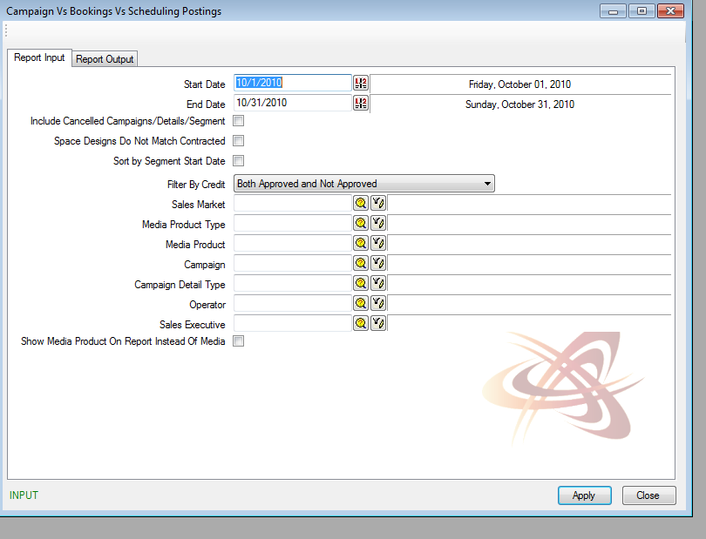

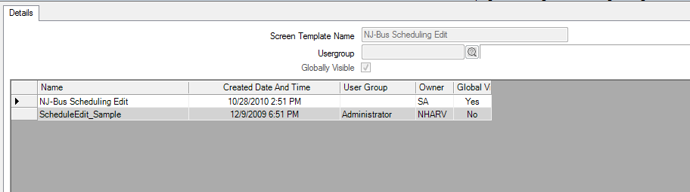

1. Opens Report with Template Settings. Sales Market, Media Product Type and Operator have been populated.

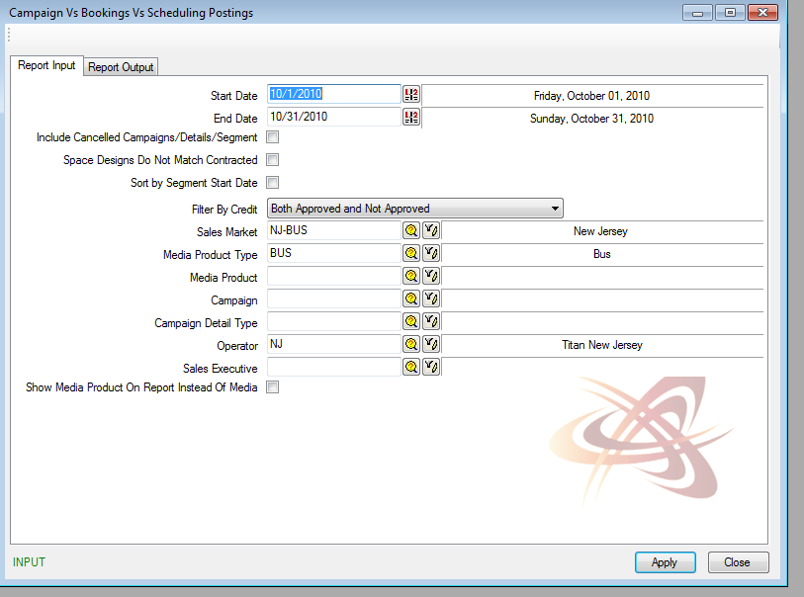

1. Select **Apply** to run your report.